San Jose State University

Department of Computer Science

Professor: Ahmad Yazdankhah

**Project: Functional Spec**

Fion Leong

Mitchell Sarmento

Naghmeh Anvari

Brendon Yim

Fall 2016

**Table of Contents**

* Table of Figures 2
* Functional Requirements 3
* Nonfunctional Requirements 4
* Use Cases 5
* Website Screenshot 13

**Table of Figures**

Figure 1 -- Home Page 13

Figure 2 -- Login Page 14

Figure 3 -- Sign up page 15

Figure 4 -- Successful Sign Up 16

Figure 5 -- Caregiver Listings 17

**Functional Requirements**

1. Create text input line for users to sign up their account. Text field require users to provide their emails and name.
2. Provide users a calendar and link into their accounts. For example, using Google calendar to work together. It will display a clear and visible schedule to users.
3. Search functions by scripting the website like indeed.com. In order to create dynamic web services to users, it is a useful way to make it.
4. Narrow search by specifying criteria such as: location, schedule, care services, etc.
5. Verify credentials of caregivers. (CNA license, background check)
6. The ability to communicate through our messaging system.
7. View schedules and availability of caregivers

**NonFunctional Requirements**

1. Response time should be quick. Usually, it takes a lot time to get data from a website. In order to provide a quick search, we are limited to show 100 search results to users.
2. A system crash will not result in data loss or data being corrupted.
3. The application should be secure since members may provide sensitive information.
4. The UI should be intuitive and easy to use. For example, character font and picture should be bigger, and reduce any unnecessary features on the web page. Keep it simple for seniors to use.

Use Cases (4)

1.

|  |  |  |  |
| --- | --- | --- | --- |
| **Use Case Name** | | SCC-login | |
| **Goal** | | | |
| This use case describes how a user logs into the SCC System. | | | |
| **Participating Actors** | | | |
| This use case starts when an actor wishes to log into SCC System. | | | |
| **Nonfunctional Requirements** | | | |
| 1. User should use a web browser like Firefox 5 or higher, Google Chrome, IE 10, and Safari. 2. System responses no longer than 15 seconds since it takes some to get a result. 3. The web page is compliant with the government section 508 rule. | | | |
| **Glossary** | | | |
| Email account, Gmail account, Password | | | |
| **Primary Flow of Events**  * The system requests that the actor enter her email and password. * The actors enter her email and password. * The system validates the entered and password and logs the actor into the system. | | | |
| **Trigger** | | | |
| **User requests to login**   * If the actor enters an invalid email and/or password, the system displays an error message. The actor can choose to either return to the beginningor cancel the login. | | | |
| **Primary Preconditions** | | | |
| User presses the submit button and is logged into the system | | | |
| **Steps** | **Action** | | **System Response** |
| 1 | Request user to enter email and password | | request |
| 2 | User enter her password and email | | Valid |
| 3 | User login SCC system to use | | running |
| 4 | User re-enter her password and email | | Error message |
| 5 |  | |  |
| **Primary Postconditions** | | | |
| The database table will be updated as user login event time. | | | |
| **Alternate Flow of Events** Forget Password  SCC system requests the user to enter email address | | | |
| **Alternate Trigger**  System check email address in its database system | | | |
| the user click on "Forget Password" button | | | |
| **Steps** | **Action** | | **System Response** |
| 1 | User was requested to enter her email | | request |
| 2 | User enter her email | | valid |
| *3* | User get a email from SCC system | |  |
| **Alternate** **Postconditions** | | | |
| If the use case was successful, the actor is now logged into the system. If not the system state is unchanged. | | | |

2.

|  |  |  |  |
| --- | --- | --- | --- |
| **Use Case Name** | | Creating an account on SCC | |
| **Goal** | | | |
| This use case describes how a user can create an account on SCC. | | | |
| **Participating Actors** | | | |
| Caregivers and Care seekers | | | |
| **Nonfunctional Requirements** | | | |
| 1. User should use a web browser like Firefox 5 or higher, IE 10, Chrome, Safari. 2. System responses no longer than 3 seconds. 3. The web page is compliant with the government section 508 rule. | | | |
| **Glossary** | | | |
|  | | | |
| **Primary Flow of Events** | | | |
| **Trigger** | | | |
| User clicks on “Create an account” | | | |
| **Primary Preconditions** | | | |
| User is on the Login page | | | |
| **Steps** | **Action** | | **System Response** |
| 1 | User will type in their information, first name, email, phone number, etc. to corresponding text fields | | Waiting for user to finish inputting data |
| 2 | User sets a profile image | | Allow the user to access their local storage to select an image as their profile picture |
| 3 | User types in their work experience | | Waiting for user to finish inputting data |
| 4 | User clicks on “Submit” button | | All the data that were typed into text fields will now be checked. If all the text fields with * are filled and contains the correct format, the data will be imported to the database. |
| 5 | Website will display “Your account has been successfully created. Click here to login to SCC.” | | The database has successfully created a user with the input data. |
| **Primary Postconditions** | | | |
| The system database will create a user with the input data. | | | |
| **Alternate Flow of Events** | | | |
| **Alternate Trigger** | | | |
| The user clicks on “Cancel” button | | | |
| **Steps** | **Action** | | **System Response** |
| 1 | Any inputs already in the text fields will be erased | | Deletes all the input from text fields |
| 2 | The website will redirect the user back to the login page | | No input data is stored or sent to database |
| **Alternate** **Postconditions** | | | |
| The database will not create a user with the input data. | | | |

3.

|  |  |  |  |
| --- | --- | --- | --- |
| **Use Case Name** | | User filters search results | |
| **Goal** | | | |
| This use case describes how a user can optionally filter his/her search query | | | |
| **Participating Actors** | | | |
| Caregivers and Care seekers | | | |
| **Nonfunctional Requirements** | | | |
| 1. User should use a web browser like Firefox 5 or higher, IE 10.  2. System responses no longer than 10 seconds.  3. The web page is compliant with the government section 508 rule. | | | |
| **Glossary** | | | |
| Query: The query can be based on user’s location, wage, type of care,etc. | | | |
| **Primary Flow of Events** | | | |
| **Trigger** | | | |
| User clicks on check boxes to choose different options for their query | | | |
| **Primary Preconditions** | | | |
| Users must finish all registrations | | | |
| **Steps** | **Action** | | **System Response** |
| 1 | User checks the boxes to filter results as needed | | Waits for user to finish choosing the filters |
| 2 | User presses the update button | | Sends the requested query back to the database and retrieves an updated list |
| **Primary Postconditions** | | | |
| The list of results will be updated to filtered result set. | | | |
| **Alternate Flow of Events** | | | |
| **Alternate Trigger** | | | |
| The user unchecks filters | | | |
| **Steps** | **Action** | | **System Response** |
| 1 | The user clicks on all or some of the checked boxes to uncheck | | Waits for user to finish checking or unchecking filters |
| 2 | User presses the Update button | | Sends the requested query back to the database and retrieves an updated list |
| **Alternate** **Postconditions** | | | |
| The list of result we’ll be set back to the original one or it will be updated to a different filter. | | | |

4.

|  |  |  |  |
| --- | --- | --- | --- |
| **Use Case Name** | | Setup availability | |
| **Goal** | | | |
| This use case describes how a user can setup their availability on their profile calendar | | | |
| **Participating Actors** | | | |
| Caregivers | | | |
| **Nonfunctional Requirements** | | | |
| 1. User should use a web browser like Firefox 5 or higher, IE 10.  2. System responses no longer than 10 seconds.  3. The web page is compliant with the government section 508 rule. | | | |
| **Glossary** | | | |
|  | | | |
| **Primary Flow of Events** | | | |
| **Trigger** | | | |
| User clicks on “Edit availability” button inside profile | | | |
| **Primary Preconditions** | | | |
| User is logged into the system | | | |
| **Steps** | **Action** | | **System Response** |
| 1 | User clicks on the date on the calendar | | A pop up screen will appear to choose the hours |
| 2 | User selects hours and presses “ok” | | The data will be stored in the database. |
| 3 | The website will display “Profile updated”. | | The new data will be shown to the user and the table of availability hours will be updated. |
| **Primary Postconditions** | | | |
| The database table availability will be updated with the input data. | | | |
| **Alternate Flow of Events** | | | |
| **Alternate Trigger** | | | |
| The user click on “Delete” Button | | | |
| **Steps** | **Action** | | **System Response** |
| 1 | User clicks on any of the dates to delete availability time | | Waits for the user to click on “Ok” |
| 2 | User either deletes the hours or changes the data. | | Waits for the user to click on “Ok” |
| *3* | User clicks on “Ok” | | Database will take effect by the changes. |
| **Alternate** **Postconditions** | | | |
| The database will be changed back or updated. | | | |

**Website Screenshot (5)**

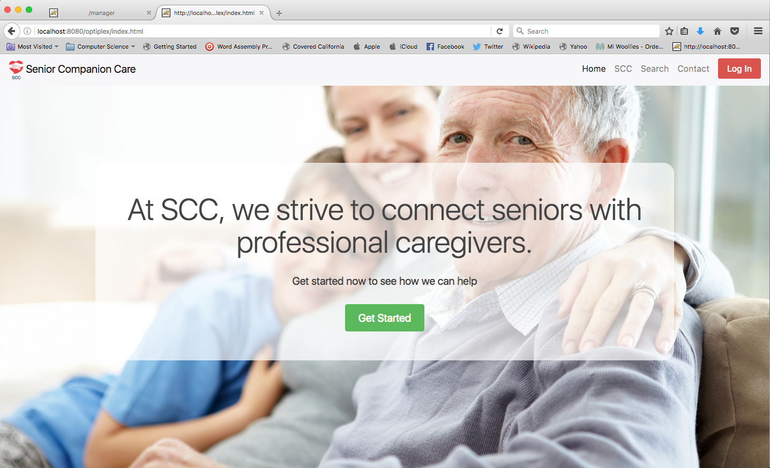

Figure 1 - Home Page

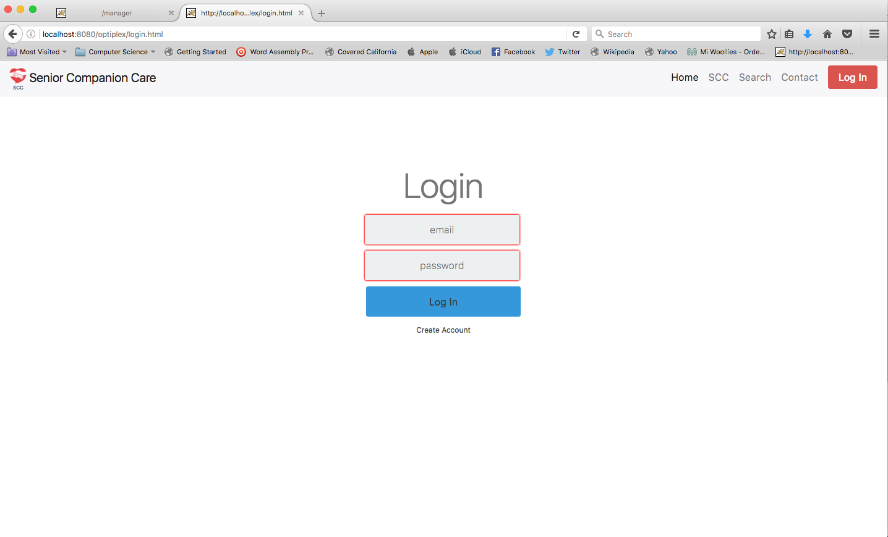

Figure 2 - Login Page

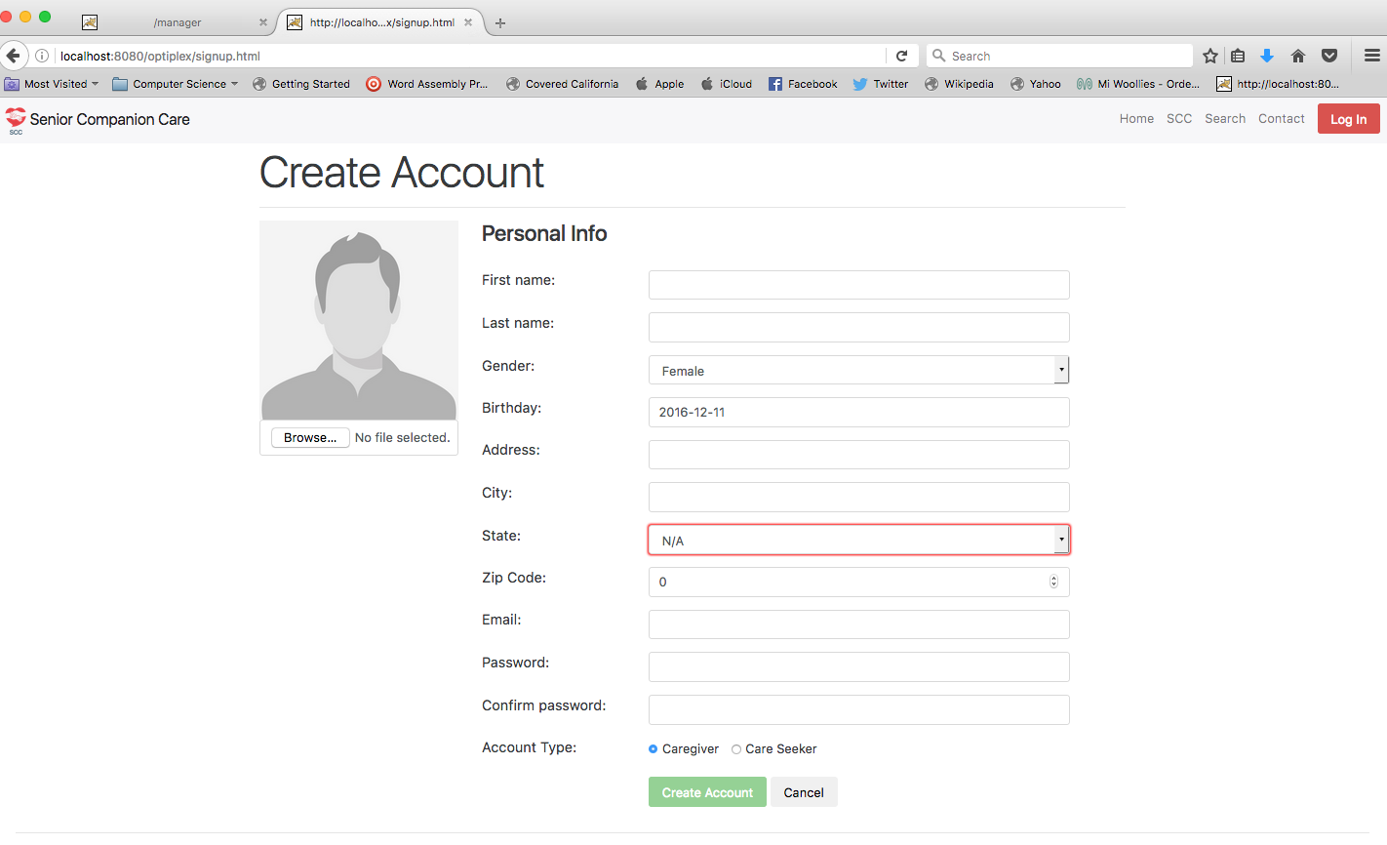

Figure 3 - Sign up page

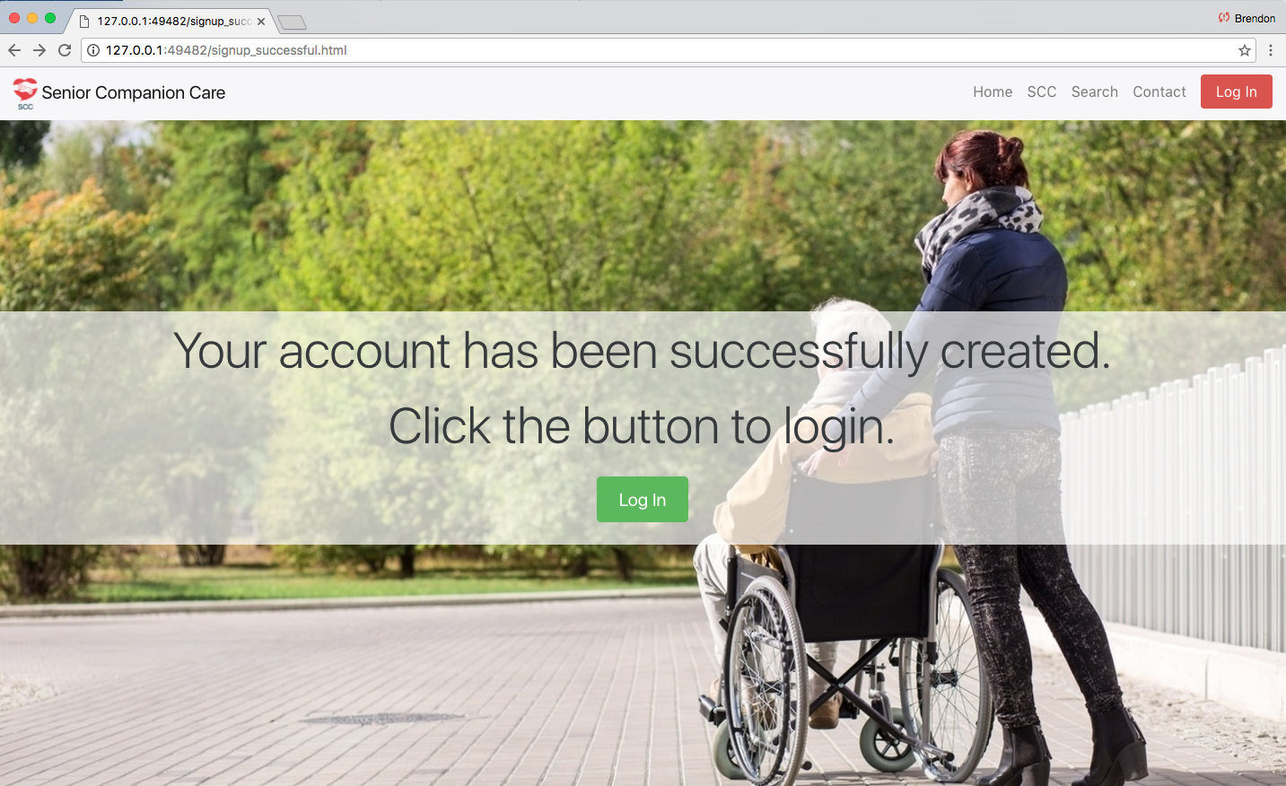

Figure 4 - Successful Sign Up

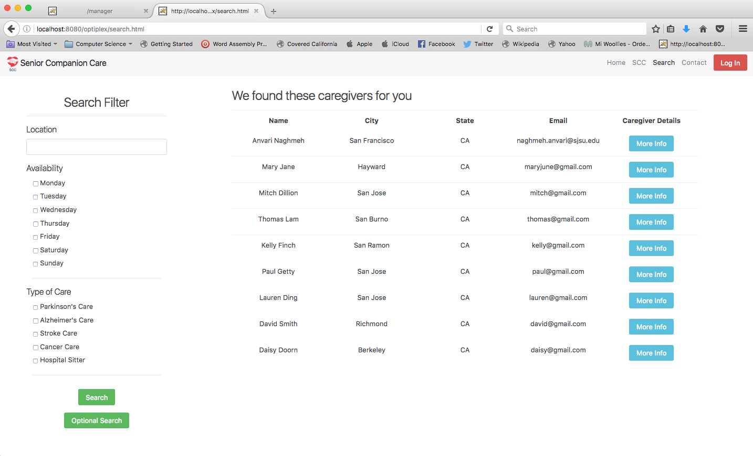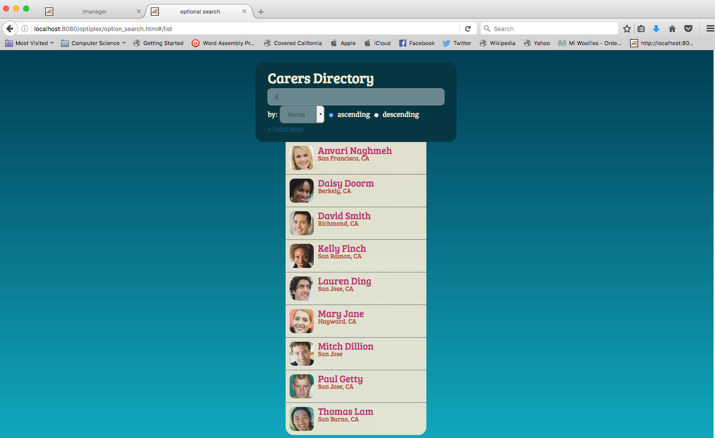

Figure 5 - Caregiver Listings